**Assignment 2**

All files and folder located within the 09018444 folder.

To run the server “node index.js” from within the folder

<http://localhost:8000>

Game setup for a minimum of 4 players.

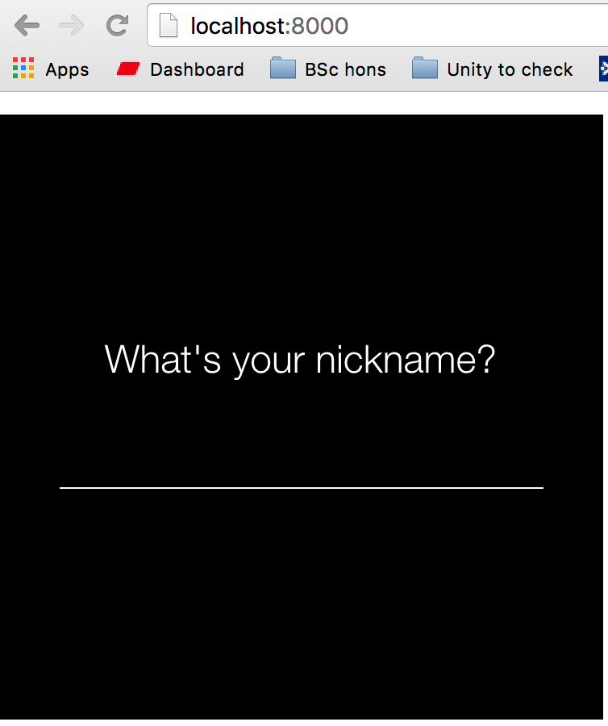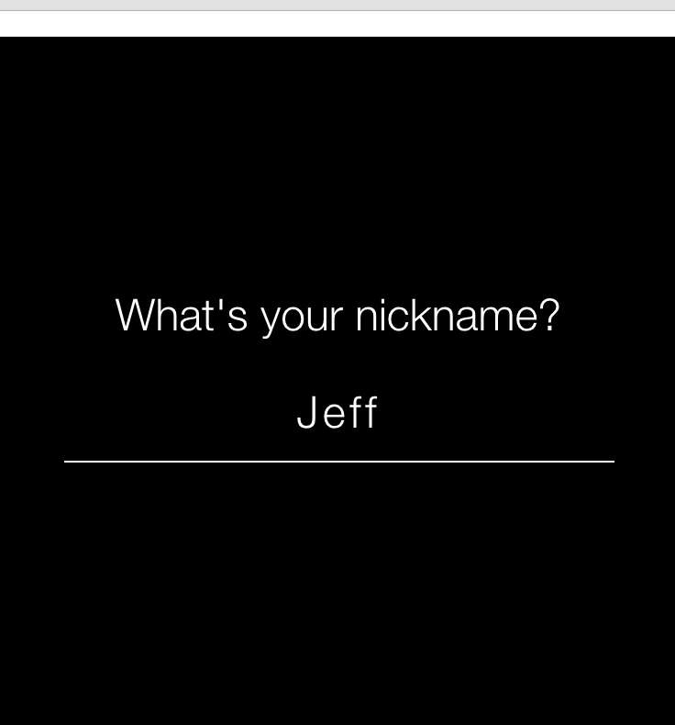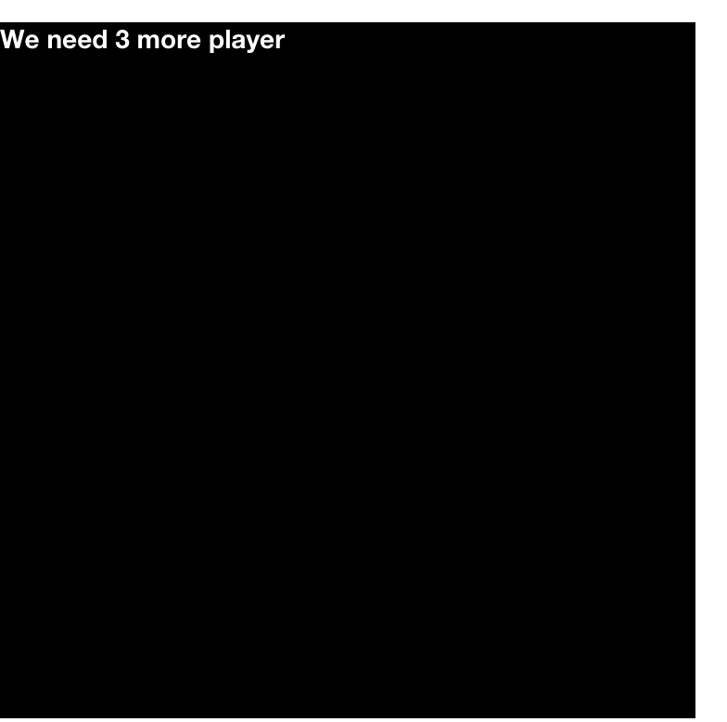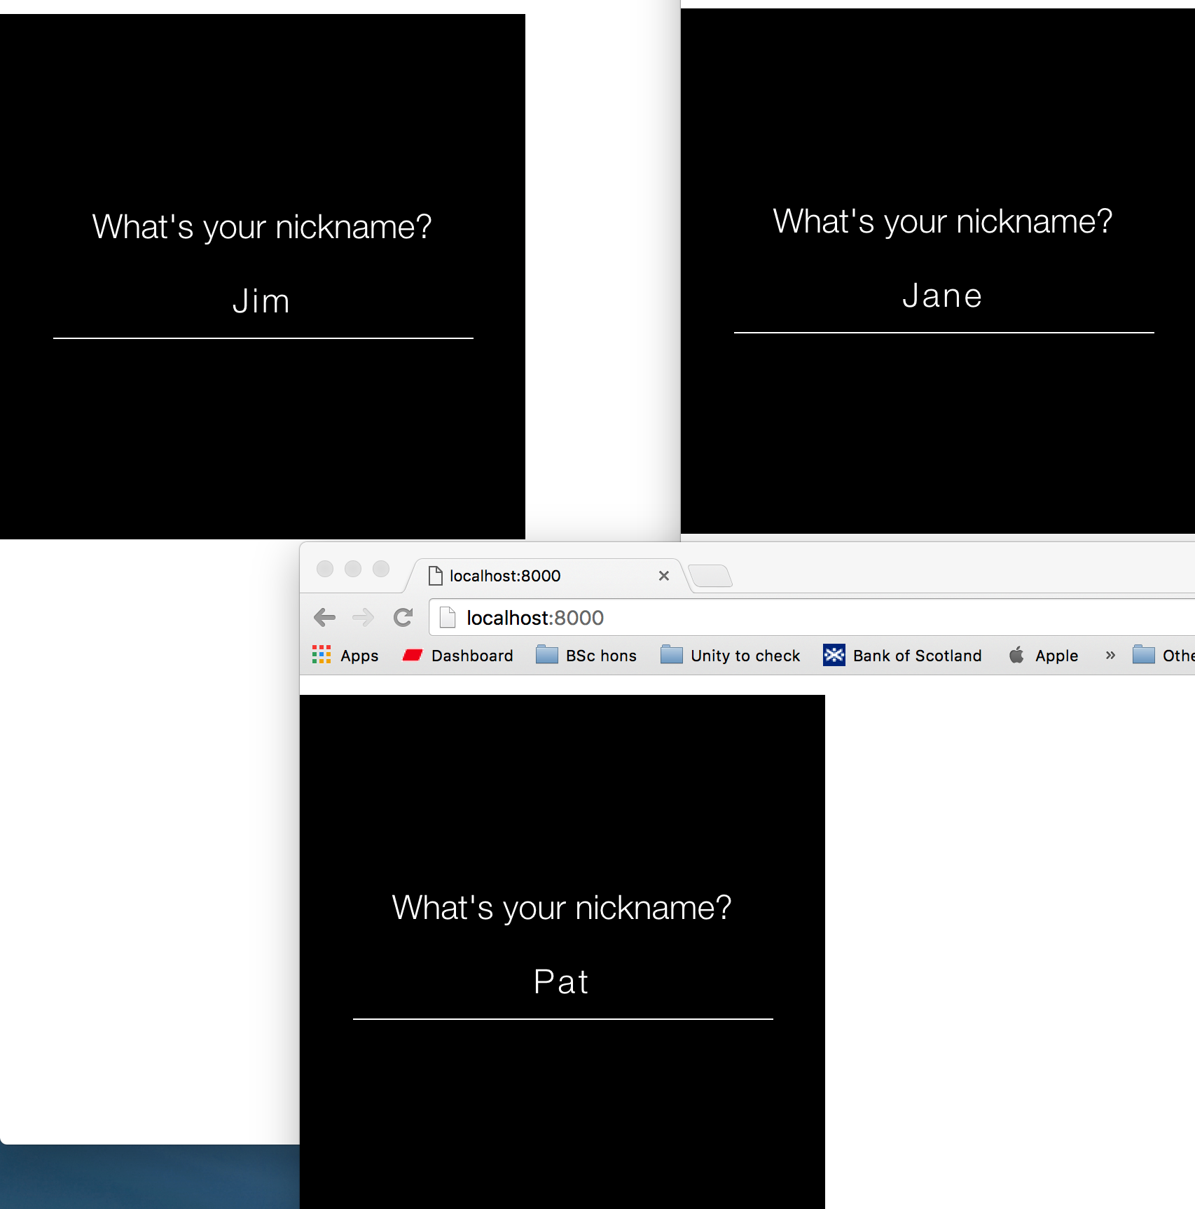

Main screen

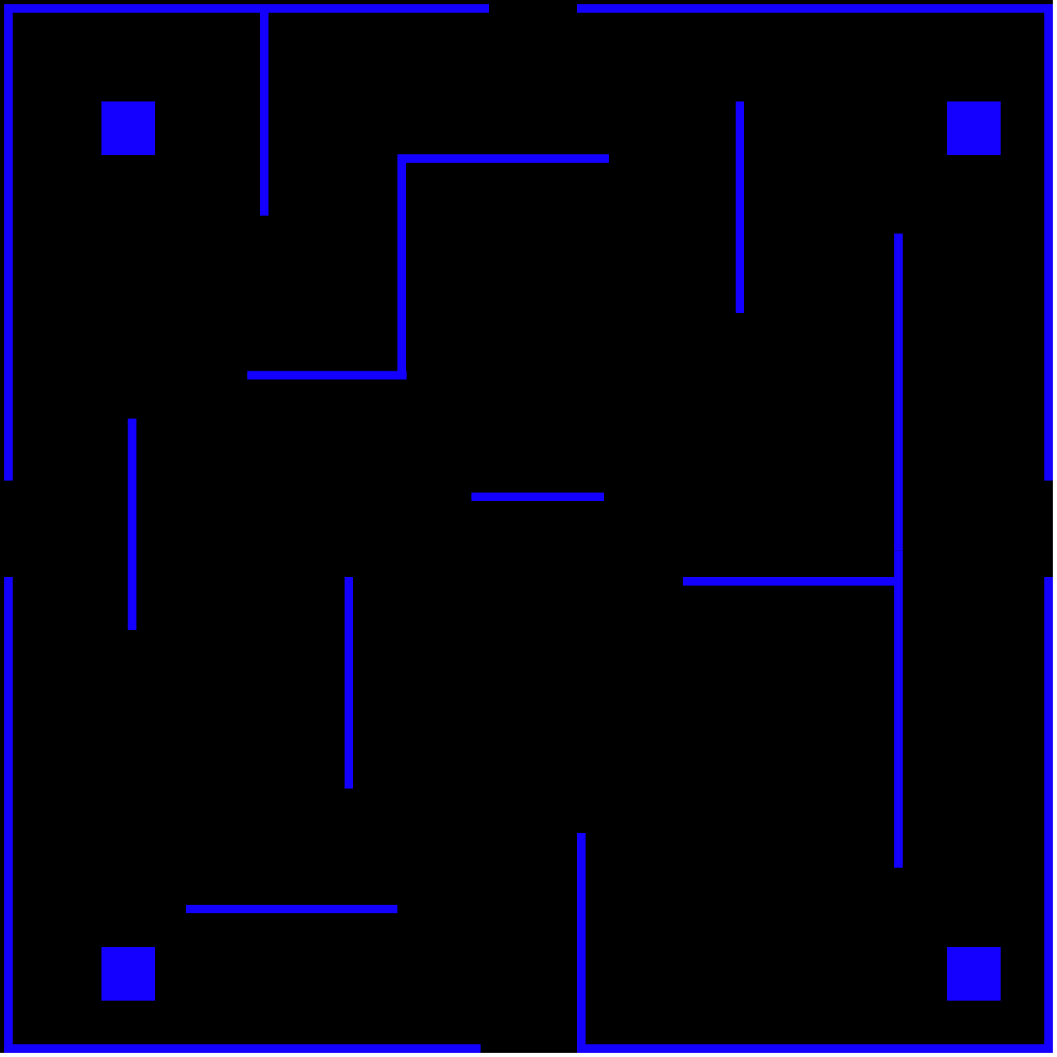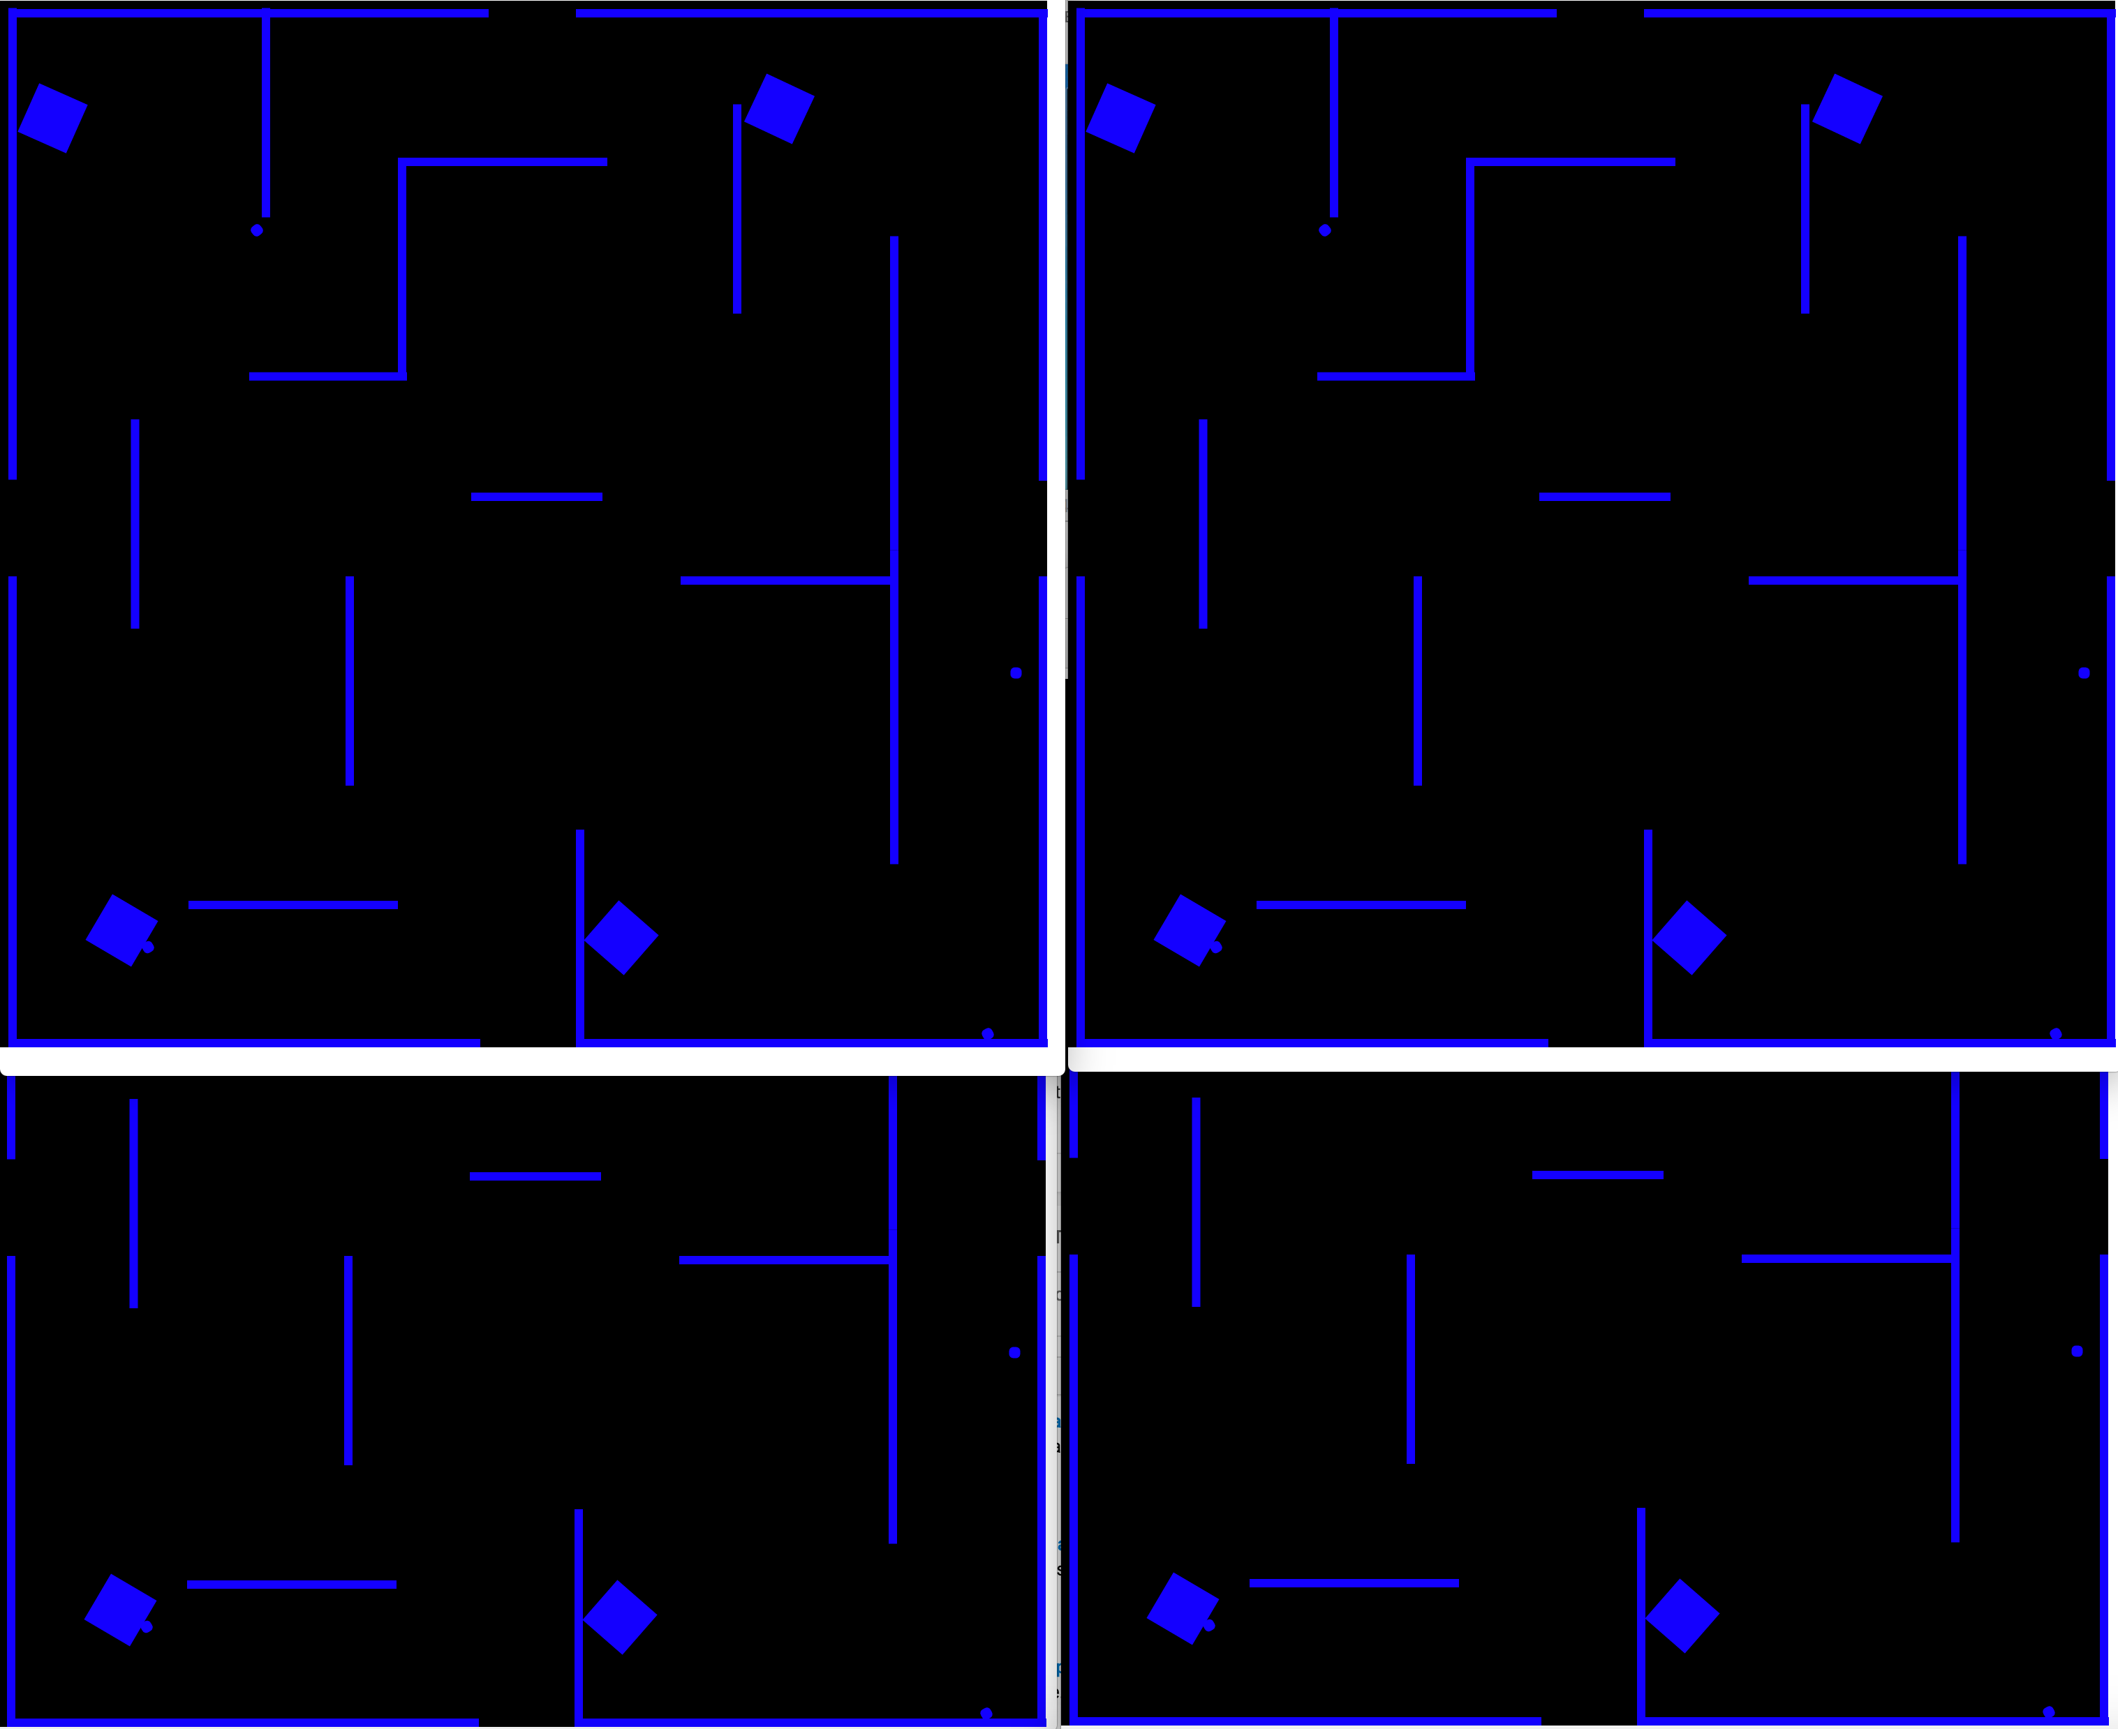

A template Box2d single player design is located in the template folder and has been used as a base for the game.

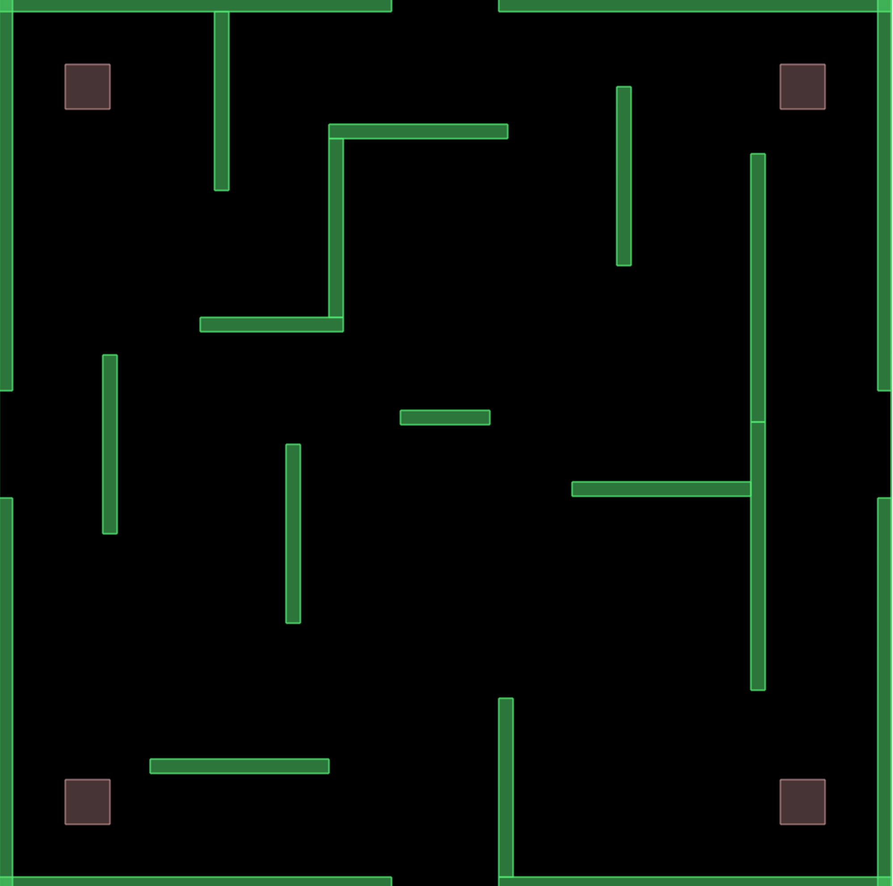

Viewpoint: C:\Users\gts25_000\AppData\Local\Microsoft\Windows\INetCache\Content.Word\start.tiffwill not follow player and has been deactivated (main.css line 18)

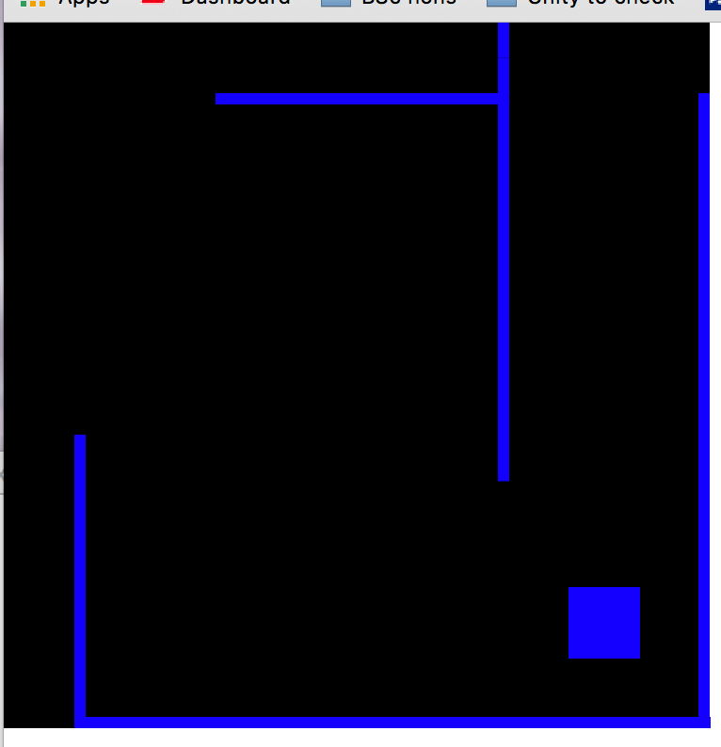

Each player can control their own tank (left, right, up, down) and fire bullets.

Despite extensive testing the destroy element in this issue only destroys other bullets. When I succeeded in destroying the bullets when they touched the boundary, the other destroy elements failed to work.

Bullet do not appear to remove health and subsequent lives, despite doing so in the template design.